More Evidence for the Report ‘Scientific Expert Report on the COVID-19 Epidemic Response in Ireland’
August 2021

The following provides supporting evidence and supplementary evidence for the ‘Scientific Expert Report on the COVID-19 Epidemic Response in Ireland’ by Jay Bhattacharya, MD, PhD and Professor of Medicine in Stanford University, USA. Approximately 33% of this Report.
Dr. Dolores Cahill, Professor of Science and Immunology, UCD. Immunologist.
Dr. Anne McCloskey, medical doctor
Dr. Patrick Morrissey, medical doctor
Mr. Edward Shanahan, Barrister in Ireland and author of Section U of this paper with assistance from David Egan MSc (NUI Galway and University of Oxford)

Effective Treatments for Covid19 including Treatments which were illegally blocked and banned in the USA and Ireland and other countries
- The prestigious American Association of Physicians and Surgeons published the following treatment guidelines for covid19 in 2020 and 2021 - https://aapsonline.org/covidpatientguide/ and https://aapsonline.org/CovidPatientTreatmentGuide.pdf
These medicines include:
- Hydroxychloroquine. And Hydroxychloroquine, AZT and Zinc combinations
- Ivermectin
- Budesonide
- Hyberbaric oxygen treatment
- Dexamethasone
- Plasma Antibody Treatment, Regeneron
- Avoidance of aggressive ARDS treatment / aggressive ventilator treatment
- Avoidance of ACE inhibitors and Statins.
- Use of Vitamin D, Vitamin C and Zinc to protect the immune system and is associated with reduced risk of severe covid19 and death.
which have been listed in our Book of Evidence and supplementary evidence.
These medicines could have saved hundreds of lives in Ireland in 2020 and 2021 and hundreds of thousands of lives worldwide. They were illegally and unlawfully blocked in 2020 and 2021. This requires criminal investigations and criminal prosecutions in the courts and in international tribunals.
- These safe and effective medicines have been confirmed to be effective against covid19 in many scientific studies and papers. This has been detailed in a legal case filed in a Federal Court in Alabama in the USA by Thomas Renz in July 2021. See title of court case below
IN THE UNITED STATES DISTRICT COURT FOR THE NORTHERN DISTRICT OF ALABAMA
AMERICA’S FRONTLINE DOCTORS, et al., Plaintiffs,
vs.
XAVIER BECERRA, Secretary of the U.S. Department of Health and Human Services, et al., Defendants.
Civil Action No. 2:21-cv-00702-CLM
Links to court paper and filing below.
https://americasfrontlinedoctors.org/wp-content/uploads/2021/07/M-for-PI-file-stamped.pdf
and https://americasfrontlinedoctors.org/files/alabama-preliminary-injunction/
and www.data-analytica.org/alabama.pdf

Open letter published in the IRISH MEDICAL TIMES

Letter: Open letter to the Minister for Health
By Contributor 20th July 2021

Blocking of use of Ivermectin

Dear Mr Donnelly;
It is now quite clear that there is a worrying and somewhat sinister attempt to block the use of Ivermectin in the prevention or treatment of SARS-CoV2 infections. This despite numerous randomised control trials,observational trials and case studies. The arguments against use include lack of evidence, clearly this isn’t the case and the safety profile. This drug is 50 years old and has resulted in approximately 20 deaths in that time. Aspirin has killed multiples of this number.

Given that much of the evidence has been in existence for at least one year, and more has subsequently emerged, I would assert that the writers of the ICGP guidelines (April 2020) and the subsequent HIQA guidelines (January 2021) are guilty of the crime of wilful blindness as defined: “The doctrine of willful blindness imputes knowledge to an accused whose suspicion is aroused to the point where he or she sees the need for further inquiries, but deliberately chooses not to make those inquiries.”
As are those who were party to sanctioning such documents. The instructions in these documents advised GPs to basically do nothing in the initial phases, except perhaps have a PCR test to confirm infection, most were not seen by their family doctors, and if they worsened were sent to hospital.

Sadly, many of those in nursing homes were not offered a hospital admission, instead were given oxygen, morphine and midazolam whilst awaiting death.
In all these cases a window of opportunity in the early stages of this condition was lost.
No doubt some of these people would have worsened and died anyway but we will never know how many could have survived because, in the main, GPs did nothing.
Yours Sincerely,
Dr William Ralph, MICGP,
The Ballagh HC,
Enniscorthy,
Wexford.
- Audio evidence attached to this Report concerning effective and safe medicines for covid19 in 2020 and 2021 on the Pat Kenny show on Newstalk radio station in August 2021 and the unlawful, illegal and unethical banning of these medicines. Evidence presented by Dr. Peter Kory a highly qualified medical doctor who is member of Front Line Covid Critical Care (FLCCC) at https://covid19criticalcare.com. Audio evidence also online at www.data-analytica.org/Radio Interview.mp3
And Newstalk radio interview on their web site at https://www.newstalk.com/news/ivermectin-expert-slams-absurd-regulatory-opposition-to-drug-that-could-end-pandemic-1238674
- The evidence shows that this banning and blocking of effective and safe medicines was intentional and deliberate so as to create mass desperation for new experimental, untested and unsafe covid19 vaccines in 2021 and massive profits and pay offs for some parties. See sections below and Criminal Intent section below.

Evidence submitted to the Investigative Corona Committee Germany regarding Coronavirus patents, the SARS patent prior to its outbreak in Asia in 2002 - 2003, Coronavirus vaccine trials and vaccine patents, Dangerous Coronavirus research, Gain of Function patents for coronaviruses including covid19 prior to 2020, Covid19 virus Patent, Covid19 vaccine development involving the spike protein prior to the Covid19 outbreak in January 2020, and Bioterrorism allegations, Lies, Deception, Insider trading and Criminal Conspiracy and Conflicts of Interest in relation to covid19
The evidence and facts gathered and presented here by Reiner Fuellmich a German and American lawyer is very similar to the evidence in criminal cases in Ireland. Reiner Fuellmich is working with other lawyers and scientists and medical doctors and professors to bring court cases against the lockdowns, PCR test frauds, deaths in nursing homes, the deliberate banning and blocking of effective and safe medicines for covid19 in 2020 and 2021 and the promotion of experimental vaccines and vaccine passports in Germany and in the international criminal court. In fact, evidence to be presented in the German courts is international in scope and can be presented in the Irish courts. The same covid19 frauds perpetrated in Germany are also occurring in Ireland and other countries.
Video presentation by Reiner Fuellmich a German and American lawyer
https://www.data-analytica.org/reiner.mp4
Reiner Fuellmich is involved with the Investigative Corona Committee Germany in Germany which is preparing expert scientific evidence for the courts and has compiled scientific reports from hundreds of scientists, medical doctors, virologists, immunologists, professors and epidemiologists and expert legal reports from lawyers in relation to:
- covid19, its Infection Fatality Rate, Hospitalization rate, Prior Immunity to covid19, Median Age of Death, Excess Mortality, Antibody studies, Deaths in Care Homes.
- ineffectiveness of defective PCR tests for covid19 with it’s high rates of false positives for covid19. The deliberate use of high cycle counts in PCR tests to get False Positives for covid19. The misuse of this to spread fear and panic.
- ineffectiveness of lockdowns
- effective medicines for covid19 since March 2020 and the illegal and unlawful blocking of these medicines
- ineffectiveness of masks
- the serious dangers and risks of covid19 vaccines. The large number of injuries and disabilities and deaths caused by these covid vaccines.
- the failure of the Imperial College London model used by the British government and by NPHET and its modellers and the Irish government. The deliberate use of false predictions and false statistics to spread fear and panic and force reluctant politicians and governments to impose lockdowns
- the criminal destruction of businesses and whole economies based on covid19 frauds and lies
- the unlawful, illegal and unConstitutional censorship of the press annd media and the Internet and of medical doctors and scientists. And the use of blackmail and extortion.
- the conflicts of interest and other corruption in relation to covid19
Scientific and medical reports and scientific findings about covid19 and related matters - https://corona-ausschuss.de/en/documents/
Web site containing scientific and legal reports, scientific and legal interviews about covid19 - https://corona-ausschuss.de/en/
These are being gathered and collated for cases in the German courts and European courts and the International court / Nuremberg 2 Tribunal and legal cases in many other countries.
New evidence and testimonies point to dangerous, illegal and unlawful virus research and vaccine research and to covid19 vaccine development prior to the covid19 outbreak in January 2020, to reckless endangerment of millions of lives and to profiteering by some parties and many conflicts of interest. This is of great importance to Ireland and the USA and many other countries.
- Testimony of Dr. David Martin to the Investigative Corona Committee Germany
https://odysee.com/@Corona-Ausschuss:3/Sitzung-60-Die-Zeit-ist-kein-flacher-Kreis-5-Martin:f?
and
https://beforeitsnews.com/health/2021/07/proof-fauci-and-pharma-running-a-rico-criminal-conspiracy-reiner-fuellmich-david-martin-3040472.html
Two important Expert Witness testimonies have been provided by Dr. Peter McCullough and Dr. David Martin in June and July 2021 to the legal team of Reiner Fuellmich and these will be used in German courts and European courts and the International court / Nuremberg 2 Tribunal. These involve
- Patents for covid19 and coronaviruses prior to the global pandemic which started in January 2020
- covid19 vaccine research prior to the pandemic starting
- gain of function research for coronaviruses (including SARS) and bioweapons research and Patents for these prior to the pandemic starting. Patents for bioweapons.
- premeditated murder of many persons through viruses with gain of functions and through covid19 vaccines. Bioterrorism against peoples and nations for profit
- the serious risks and dangers from covid19 vaccines
- political and scientific corruption in the USA and other countries.
Click on videos below:
https://www.bitchute.com/video/oeUkkFo68lL7/
https://www.bitchute.com/video/9HxsE5llViby/
and https://www.bitchute.com/video/6MS6wiOFb3dI/
These are very serious criminal charges which need to be brought into the criminal courts in Ireland and other countries.
More video interviews by the Corona Committee Germany and by Reiner Fuellmich and his legal team on: https://www.bitchute.com/search/?query=german%20corona%20committee&kind=video
https://www.bitchute.com/search/?query=corona%20committee%20germany&kind=video
https://www.bitchute.com/search/?query=reiner%20fuellmich&kind=video
Dr. Peter McCullough and Dr. David Martin and other Experts who testified for the Corona Committee Germany will be subpoenaed into the Irish courts to testify.
The PCR Test for covid19 being used in Ireland is the subject of a Cease and Desist case and a Fraud case for the courts in Germany. Documents attached in link.
https://journal.ratical.earth/2021/01/04/cease-desist-order-to-prof-dr-christian-drosten-creator-of-sars-cov-2-pcr-test
Spanish University Scientists find Graphene Oxide in Pfizer covid19 vaccines
Scientists are the University of Almeria in Spain have found that Pfizer covid19 vaccines contain over 95% Graphene Oxide. This is toxic to human cells and the human body. The scientific findings are on
https://www.docdroid.net/rNgtxyh/microscopia-de-vial-corminaty-dr-campra-firma-e-1-fusionado-pdf and www.data-anayltica.org/graphene-oxide.pdf
and a video interview on https://odysee.com/@laquintacolumna:8/CONTENIDODELAVACUNASEG%C3%9ANINFORMEPRELIMINARUNIVERSIDADDEALMER%C3%8DA:1?r=8qjPwG8VB8Z9EGGQPLU4DVo5hYpAPjde and
and this American news channel at https://www.bitchute.com/video/RMbGBOVyCNtV/
Scientific papers on Graphene oxide toxicity to human
Toxicity of graphene-family nanoparticles: a general review of the origins and mechanisms
Ou et al. 2016 BMC https://particleandfibretoxicology.biomedcentral.com/articles/10.1186/s12989-016-0168-y
https://www.google.com/search?client=firefox-b-d&q=graphene+oxide+toxicity
https://yandex.com/search/?text=graphene%20oxide%20toxicity&lr=105201
https://duckduckgo.com/?q=graphene+oxide+toxicity&t=h_&ia=web
The Spanish scientists from the University of Almeria in Spain will be subpoenaed into the Irish courts to testify.
Massive Increase in Covid19 Vaccine Deaths in USA in July 2021. Federal court case about this is proceeding in the USA. More Corroboration of our Evidence and Findings in Ireland in the Federal Court papers filed in the USA.
In July 2021, an American lawyer Thomas Renz filed papers with a federal court in Alabama in USA stating that 45,000 people died within 3 days of taking the covid19 vaccine and he has a whistleblower and a sworn affidavit attesting to this. This is initiating FBI and law enforcement investigations and federal court hearings for later this year. These 45,000 vaccine deaths are just one government reporting system. There are several other government reporting systems tracking vaccine deaths and there could be thousands more in each of these reporting systems. The real figures for covid19 vaccine deaths could be as high as 100,000 in July 2021. Allegations are being made that the CDC and government authorities are covering up these vaccine deaths.

The figure of 45,000 vaccine deaths is a massive increase in deaths and provides more evidence of the dangers of these covid19 vaccines. The legal papers filed with the court also detail PCR test frauds which gave high False Positives for covid19, the mislabeling of other illnesses and diseases and deaths as covid19, the lies about asymptomatic spread, the false and fraudulent reasons for lookdowns , the unlawful blocking of effective and safe medicines for covid19, and other frauds and crimes associated with covid19. This corroborates the evidence in our Book of Evidence and supplementary evidence given to the Irish Police and DPP in 2021.
This case is due before the federal courts later this year in 2021. Title of Court case below:
IN THE UNITED STATES DISTRICT COURT FOR THE NORTHERN DISTRICT OF ALABAMA
AMERICA’S FRONTLINE DOCTORS, et al., Plaintiffs,
vs.
XAVIER BECERRA, Secretary of the U.S. Department of Health and Human Services, et al., Defendants.
Civil Action No. 2:21-cv-00702-CLM
Links to court paper and filing below.
https://americasfrontlinedoctors.org/wp-content/uploads/2021/07/M-for-PI-file-stamped.pdf
and https://americasfrontlinedoctors.org/files/alabama-preliminary-injunction/
and www.data-analytica.org/alabama.pdf
and news stories about this at https://www.bitchute.com/search/?query=thomas%20renz&kind=video

These high numbers of covid19 vaccine deaths in the USA have massive ramifications for Ireland and other countries. We attach the US court papers filed in the federal court in Alabama in the USA to our legal case and court case in Ireland, to be used as corroborating evidence in the Irish courts.
Miscarriages and Loss of Babies after covid19 vaccinations
A scientific paper published in June 2021 showed that 82% of pregnant and vaccinated women lost their babies. This is a disturbing finding. I include lin to scientific paper below
Preliminary Findings of mRNA Covid-19 Vaccine Safety in Pregnant Persons
Shimabukuro TT, Kim SY, Myers TR, Moro PL, Oduyebo T, Panagiotakopoulos L, Marquez PL, Olson CK, Liu R, Chang KT, Ellington SR, Burkel VK, Smoots AN, Green CJ, Licata C, Zhang BC.
N Engl J Med. 2021 Jun 17;384(24):2273-2282. doi: 10.1056/NEJMoa2104983. Epub 2021 Apr 21. PMID: 33882218; PMCID: PMC8117969.
https://pubmed.ncbi.nlm.nih.gov/33882218/ and news report about this https://whiskeytangotexas.com/2021/06/30/huge-red-flag-medical-researchers-caught-burying-data-proving-82-miscarriage-rate-in-jabbed-expectant-mothers/
A freedom of information request made to the MHRA in Britain has revealed just how deadly the Covid-19 vaccines really are compared to other vaccines for the last 20 years
The request made by Duncan Husband on the 29th May 2021 asked the MHRA to provide a list of all new vaccines in the UK between 2010 and 2020 and to also provide the number of deaths, per vaccine, per month for the same time frame.
News report: https://dailyexpose.co.uk/2021/07/11/fact-deaths-due-to-the-covid-vaccines-in-the-uk-after-6-months-are-407-higher-than-deaths-due-to-all-other-vaccines-combined-in-the-past-11-years/
More people have died of the covid19 vaccine than from all vaccines for the last 30 years in Britain. This has important ramifications for Ireland and the Irish people as we are close neighbours of Britain and have similar health, diet and lifestyle and healthcare systems. Vaccine deaths on this scale need to be brought to the attention of the Irish police and prosecutors and legal system and courts and the general public.
THis corroborates the evidence in the USA and worldwide, see sections below.

Covid19 Vaccine Deaths Injuries and Disabilities Worldwide
Does 2021 look normal to you the reader and to members of the police and the Prosecutors office and the court ? Normally, once over 50 people die, they stop the vaccine.
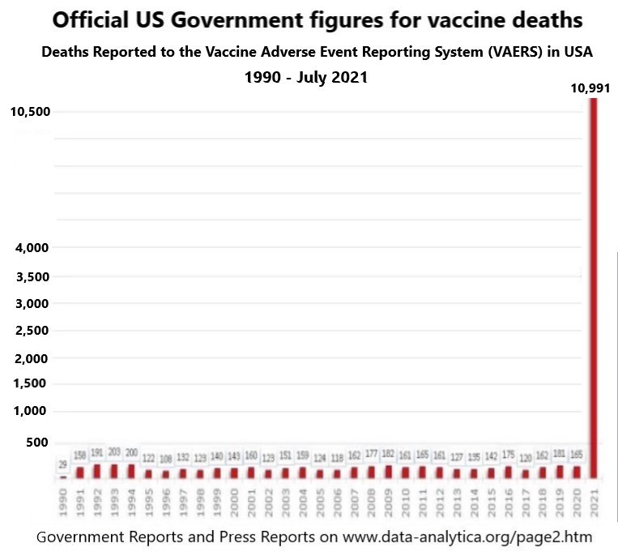
Vaccine deaths on this scale need to be brought to the attention of the Irish police and prosecutors and legal system and courts and the general public.
Findings worldwide are corroborating this. See image below
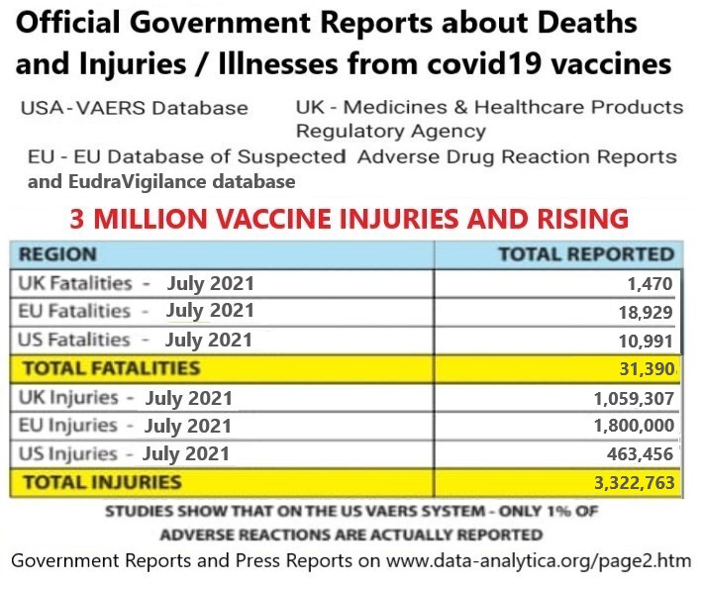
Absolute Reduction Risk (ARR) of covid19 vaccines
Absolute Reduction Risk (ARR) measures the vaccine effectiveness against covid19. According to a study published by the NIH, the ARR for the Pfizer Vaccine is a mere 0.7%, and the ARR for the Moderna Vaccine is only 1.1%. This is very tiny and provides very little or no protection. The covid19 vaccines provide no real benefit or protection from covid19 but the vaccines pose moderate to high risks of vaccine injuries, illnesses and death. For children and young adults these risks are high when compared to the risk from covid19. Imposing vaccine passports on everybody for this is a fraud and a crime.
Important Lecture about pre-existing immunity to covid19 among most of the population and covid19 vaccine dangers by Dr. Sucharit Bhakdi, Medical Professor in Germany in July 2021
Lecture in this video - https://tube.doctors4covidethics.org/videos/watch/7ca43fab-fa9d-46e6-ac7a-a0c739d9e277
This corroborates our evidence in our Book of Evidence and in additional evidence. He can be subpoenaed into Irish courts.
Increase in Hospital admissions, injuries, new illnesses and deaths in 2021 caused by covid19 vaccines. Covid19 vaccine injuries and deaths are being classified as ‘new variants’ of covid19 and this may be used to enforce more lockdowns in 2021 and 2022

There is evidence of increased hospital admissions in Ireland and Britain among those who were vaccinated with covid19 vaccines since late January 2021. There are correlations between the covid19 vaccines and the spread of new variants of covid19 in countries around the world and this evidence was supplied in the previous Supplementary Evidence submitted to the police in Ireland and is also available on www.data-analytics.org/evidence.htm and on www.data-analytica.org/page2.htm
The so called "variants" are the result of defective PCR tests with a high rate of False Positives as high as 97% in Ireland and other countries using cycle counts of 35 to 45.
The deaths and injuries and hospitalizations from the covid19 vaccines need to be more carefully monitored and tracked in Ireland.
- Every person hospitalized within 20 months of getting the covid19 vaccines should be investigated and monitored for covid19 vaccine injuries / illness / disability caused by the covid19 vaccine. Long term tracking and studies should extend for 5 - 10 years after vaccination for scientific and medical reasons.
- Every person who dies within 20 months of getting the covid19 vaccines should be investigated and monitored for covid19 vaccine caused death. Long term tracking and studies should extend from 5 – 10 years for scientific and medical reasons. Autopsies of dead covid19 vaccinated people must be made mandatory under law.
- Every person who attends a medical doctors clinic for serious illnesses or new disability within 20 months of getting the covid19 vaccines should be investigated and monitored for covid19 vaccine injuries / illness / disability caused by the covid19 vaccine. Long term tracking and studies should extend for 5 - 10 years after vaccination for scientific and medical reasons.
- How many covid19 vaccine deaths and injuries and disabilities are being mislabeled as covid19 or covid19 variants ? The mislabeling of covid19 vaccine deaths and injuries and disabilities as covid19 or variants of covid19 can be used to keep this ‘pandemic’ going indefinitely for more years and enforce more lookdowns.
- The main causes of covid19 vaccine injuries, disabilities and deaths are
(a) the spike proteins in the organs and blood vessels of the body and the complications, clotting, hemorrhages, new diseases and inflammatory damage they cause including significant damage to the nervous system and vascular system and reproductive system
(b) the Antibody-dependent enhancement (ADE) that this vaccine causes. Scientific trials of similar vaccines in the past for SARS 1 (covid19 is SARS 2) showed that Antibody Dependent Enhancement (ADE) led to high death rates among animals when exposed to wild forms of SARS. The same risks of Antibody Dependent Enhancement (ADE) and deaths / serious injuries apply to the present covid19 vaccines especially in Winter and Spring. ADE is believed by top scientists to be playing a significant role in the generation of new variants of covid19.
(c) the toxicity of the grapheme oxide in the vaccines.
(d) Vaccine-driven disease enhancement in the previously infected
These injuries and damage and deaths are summarised by scientists in a scientific analysis document developed by British scientists in May 2021 and available at http://data-analytica.org/expert-report.pdf
Are Covid Vaccine injuries and disabilities and deaths being mislabeled as covid19 or new variants of covid19? The graph below shows a rise in alleged “covid19” among the vaccinated in Britain and a decline in alleged “covid19” among the unvaccinated in 2021.
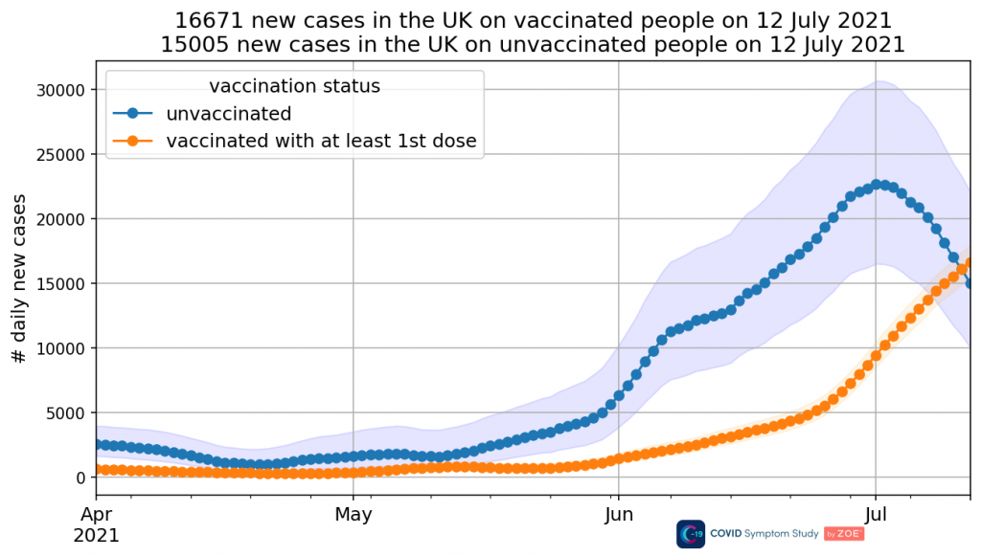
A news report about this in Britain provides more analysis of this at https://www.conservativewoman.co.uk/infections-in-the-vaccinated-overtake-those-in-the-unvaccinated-for-the-first-time-but-the-graph-is-removed-from-the-zoe-app-report/
and at https://www.youtube.com/watch?v=gwUSC6rid4A
and more news about this at https://www.pulsetoday.co.uk/news/clinical-areas/immunology-and-vaccines/gps-and-data-indicate-continued-rise-in-double-vaccinated-covid-cases/
and https://www.pulsetoday.co.uk/news/clinical-areas/immunology-and-vaccines/gps-and-data-indicate-continued-rise-in-double-vaccinated-covid-cases/
and https://duckduckgo.com/?q=vaccinated+covid+infections&t=h_&ia=web
and https://yandex.com/search/?text=vaccinated+covid+infections&lr=101489
Public statement by Irish nurses and healthcare workers to the general public, the Gardai and the Irish Times
We attach a public statement about the handling of covid19 in Ireland and covid vaccines in Ireland by concerned nurses and healthcare workers. It alleges criminal wrong doing, malpractise, and breaches of medical ethics. This public statement corroborates our evidence presented to the gardai and prepared for the Irish courts. It can be downloaded at www.data-analytica.org/nurses.doc

Top Scientists and Doctors and Professors in USA call for a total revision of the criteria for authorizing the covid19 vaccines by FDA based on new data showing serious risks and dangers from these vaccines
- https://downloads.regulations.gov/FDA-2021-P-0521-0001/attachment_1.pdf
and www.data-analytica.org/FDA.pdf
This corroborates our evidence in the Book of Evidence given to the Irish police and DPP in2021

Public Statements about covid19 and covid19 vaccines by Organisations run by Top Scientists and Medical Doctors which have serious legal consequences in countries worldwide including Ireland
The evidence they present corroborates our evidence given to the Irish police and legal authorities. Giving vaccines which can cause deaths and injuries or disabilities without informing people about these dangers constitutes the crime of poisoning and manslaughter / murder. Continuing to administer dangerous vaccines may also constitute the crime of poisoning and manslaughter / murder.
- Vaccine Truth - https://trialsitenews.com/vaccine-truth-cdc/
- Doctors For Covid Ethics - https://doctors4covidethics.org/ and https://principia-scientific.com/four-new-discoveries-about-safety-and-efficacy-of-covid-vaccines/
- The HART group in Britain - https://www.hartgroup.org
- Israeli People’s Committee web site
- Frontline COVID-19 Critical Care Alliance web site https://covid19criticalcare.com

Exposure of Lies about covid19 numbers

Leo: Covid cases in hospital counted even when patients admitted for other reasons
Gript July 2021
https://gript.ie/leo-covid-cases-in-hospital-counted-even-when-patients-admitted-for-other-reasons/

Attached DVD of Leo Varadkar admitting in Dail Eireann that most covid19 cases were not covid19 cases but other serious illnesses and lethal illnesses. This amounts to fraud, mass fraud which is a criminal offence. This corroborates the False Statistics criminal charge which we filed with the Irish police in May 2021.
And there is also a Bitchute video of same at https://www.bitchute.com/video/oWkDtRDrWSfV/

Exclusive: Over half of Covid hospitalisations tested positive after admission :
Leaked data suggest vast numbers classed as being hospitalised by the virus when they were admitted with other ailments
The Telegraph July 2021
https://www.telegraph.co.uk/news/2021/07/26/exclusive-half-covid-hospitalisations-tested-positive-admission/

Alleged Covid19 deaths in 2020. It is alleged but not proven by the CSO that 1,672 people died of covid19 in 2020. HSE statistics stated that 94% of covid19 deaths in 2020 had 2 or more serious underlying illnesses which were capable of causing death. Only 6% died of covid19 and nothing else. This was stated in our Report or Book of Evidence. 31,765 people died in 2020.
6% of 1672 is 100 people.
100 is 0.31% of 31,765. This is the percentage who died of covid19 only and nothing else.

Frauds which led to the Imposition of Vaccine Passports in Ireland. In Law, Fraud Vitiates Everything.
There are serious legal problems with the proposed legislation enforcing vaccine passports and discrimination and apartheid. It is based on and proceeds from a fraud – the fraudulent PCR tests and high rate of False Positives as high as 97% in Ireland and other countries using cycle counts of 35 to 45. In law, fraud vitiates everything. The vaccine passports and discrimination and apartheid can be struck down and declared null and void by the courts on this basis.

In a famous court case in Alberta Canada Deena Hinshaw vs Patrick king in July 2021, the court ruled that the Canadian government had no evidence that sars-cov2 virus or covid19 virus existed as it had NOT been isolated and purified and its full genome identified. The virus has not been proven to exist. This was accepted by the prosecutor and the defendant and the judge in court. The court accepted and ruled that they have no evidence of this virus. This has serious implications for courts in Ireland and in many other countries. And serious implications for laws and guidelines based on this virus meaning they are illegal and unlawful.
News Reports about this on Bitchute
https://www.bitchute.com/video/pGITK5Z7l2rj/
and https://www.bitchute.com/search/?query=patrick%20king%20&kind=video&sort=new

The covid19 vaccines got Emergency Use Authorisation in the EU and North America and in many countries worldwide they are not fully approved. These are not fully approved vaccines. The vaccines have not been safety tested and are experimental. It normally takes 3 – 5 years to fully test a new vaccine. The covid19 vaccines do not stimulate the body to produce immunity from a disease. They are a synthetic fragment of nucleic acid embedded in a fat carrier that is introduced into human cells, not for the purpose of inducing immunity from infection with the SARS-CoV-2 virus, and not to block further transmission of the virus, but in order to lessen the symptoms of COVID-19. No published, peer-reviewed studies prove that the “Pfizer-BioNTech COVID-19 Vaccine” and the “Moderna COVID-19 Vaccine” confer immunity or stop transmission.
The graph below shows a rise in alleged “covid19” among the vaccinated in Britain and a decline in alleged “covid19” among the unvaccinated in 2021. It portrays the ineffectiveness of covid19 vaccines.

A news report about this in Britain provides more analysis of this at https://www.conservativewoman.co.uk/infections-in-the-vaccinated-overtake-those-in-the-unvaccinated-for-the-first-time-but-the-graph-is-removed-from-the-zoe-app-report/
and at https://www.youtube.com/watch?v=gwUSC6rid4A
Massive increase in covid19 infections among covid19 vaccinated in Israel - https://dailysceptic.org/2021/07/05/pfizer-vaccine-effectiveness-drops-to-64-in-israel/
and https://www.reuters.com/world/middle-east/israel-sees-drop-pfizer-vaccine-protection-against-infections-still-strong-2021-07-05/
and ‘More than 1,000 Israelis test positive for COVID Jerusalem Post’, July 2021 at https://www.jpost.com/breaking-news/for-first-time-since-march-855-new-coronavirus-cases-in-israel-674084 . Excerpt below:

At the moment, around 60% of the patients in serious conditions have been vaccinated. Moreover, according to Hebrew University researchers who advise the government, around 90% of newly infected people over the age of 50 are fully vaccinated.

Over 3,800 Germans got sick with Covid-19 following full vaccination, hundreds were hospitalized – health watchdog
Source: https://www.rt.com/news/528729-germans-sick-covid-full-vaccination/

There have also been major covid19 outbreaks in highly vaccinated countries like Bahrain, Seychelles, Maldives and Chile
Source: https://ourworldindata.org/explorers/coronavirus-data-explorer?zoomToSelection=true&pickerSort=asc&pickerMetric=location&hideControls=true&Interval=7-day+rolling+average&Relative+to+Population=true&Align+outbreaks=false&country=SYC~MDV~BHR~CHL~GBR&Metric=Confirmed+cases

CDC identifies only 10,000 COVID-19 infections in fully vaccinated, but likely an undercount
https://thehill.com/policy/healthcare/555273-cdc-identifies-only-10000-covid-infections-in-fully-vaccinated-but-likely
The Hill, May 25 2021
and more news about this at https://www.pulsetoday.co.uk/news/clinical-areas/immunology-and-vaccines/gps-and-data-indicate-continued-rise-in-double-vaccinated-covid-cases/
and https://duckduckgo.com/?q=vaccinated+covid+infections&t=h_&ia=web
and https://yandex.com/search/?text=vaccinated+covid+infections&lr=101489
These covid19 infections of the covid vaccinated are being referred to as “breakthrough infections” and have been described by Dr. Geert VanDen Bossche in previous evidence submitted by us.

CDC releases study showing 3/4 covid19 Delta cases are among the vaccinated.
RT News July 2021
https://www.rt.com/usa/530741-cdc-vaccine-delta-study-masks/

CDC study shows 74% of people infected in Massachusetts Covid outbreak were fully vaccinated
CNBC July 2021
https://www.cnbc.com/2021/07/30/cdc-study-shows-74percent-of-people-infected-in-massachusetts-covid-outbreak-were-fully-vaccinated.html

Ineffectiveness of rushed and experimental covid19 vaccines
CDC says fully vaccinated people spread the Delta variant and should wear masks: 'This new science is worrisome'
Yahoo News, July 27 2021. https://www.yahoo.com/news/cdc-says-fully-vaccinated-people-201508057.html and https://www.businessinsider.com/cdc-fully-vaccinated-new-guidelines-wear-masks-indoors-delta-2021-7 and
CDC web site https://www.cdc.gov/coronavirus/2019-ncov/vaccines/fully-vaccinated-guidance.html

In August 2021 Dr. Anthony Fauci the head of the NIH in the USA announced that vaccinated people are getting infected and spreading the covid19 as much as the unvaccinated people. This has been reported in the American press and media and international press. This means vaccinated people are as protected as the unvaccinated and that the covid vaccines are ineffective. Scientists now believe that the new variants of covid19 can evade the vaccines. Vaccine passports for covid19 are ineffective and useless and serve only to enrich vaccine makers and their supporters and create a system of apartheid in countries.
News reports on this in links below
https://www.google.com/search?q=fauci+vaccinated+and+unvaccinated+nasopharynx
https://yandex.com/search/?text=fauci+vaccinated+and+unvaccinated+nasopharynx

A recently published scientific paper confirms this -
COVID-19 vaccines dampen genomic diversity of SARS-CoV-2: Unvaccinated patients exhibit more antigenic mutational variance, Niesen et al. July 2021, https://www.medrxiv.org/content/10.1101/2021.07.01.21259833v1
Using vaccine passports for experimental, mostly ineffective and unsafe covid19 vaccines to discriminate against people in the provision of goods and services is discriminatory and is breach of existing laws and the Constitution including :
- the Equal Status Acts
- the Irish Constitution
- EU Charter of Fundamental Rights
- the Nuremburg Code
- EU and UN Human Rights
- GDPR
- Council of Europe Resolution 2361 of 2021
- important court precedents such as GLADYS RYAN v. THE ATTORNEY GENERAL.
The new law creates a system of apartheid and it can and will be challenged in the courts. There will also be criminal court cases to address the breaches of important rights and the criminalization of innocent people and the resulting deaths and injuries from HSE and government policies detailed in this paper.
Secondly the Irish Government and HSE have no means of determining who has recovered from covid19 as the scientific literature and published scientific research shows that there was pre-existing immunity to coronaviruses and covid19 prior to March 2020, that is both normal antibody immunity and T cell immunity, and many people as much as 30% of the population got covid19 infections and recovered without experiencing symptoms or realising that they had it. So the Government and HSE cannot determine who has recovered as a high percentage of the population do not know that they had the covid19 infection and recovered. This is what is termed pre-existing immunity by scientists and medical doctors. Scientific studies now show that recovered people have strong and lasting immunity to covid19. See recent study at Quantifying the risk of SARS-CoV-2 reinfection over time, Murchu et al. 2021 at https://pubmed.ncbi.nlm.nih.gov/34043841/ . Pre-existing immunity to coronaviruses including covid19 confers similar immunity to people many of whom recovered without realizing it.

The Government’s legislation would discriminate against persons who recovered from covid19 as they had pre-existing immunity to it. But no certificates or passports to prove their pre-existing immunity. Yet the new law claims to be doing the opposite – allowing recovered people to access indoor dining and pubs and foreign travel. This creates a serious contradiction in the law and would bring the law into disrepute. The judges and courts will not support this legislation on these grounds. Courts will strike down this law.
High numbers of “Breakthrough infections” of covid vaccinated people in Ireland and abroad means the covid19 vaccines are ineffective. Though there are concerns among scientists and doctors that many of these “Breakthrough infections” may be covid vaccine injuries, illnesses and deaths mislabeled as covid19 through defective PCR tests.
In relation to “variants” of covid19 which are being used to scare the Irish population and continue the social restrictions and lockdowns, there are serious concerns being expressed by top scientists and medical doctors
(a) mislabeling of covid vaccine deaths and injuries and illnesses as covid19 or variants of covid19
(b) the defective PCR tests for covid19 which have high False Positive rates as high as 97% for Ireland which uses cycle counts of 35 - 45. These False Positives are manufacturing more and more variants and will manufacture more “variants” here in Ireland and abroad and keep this scaremongering going indefinitely for another year or for several more years. A defective test and false results for “variants” could continue indefinitely.
This has created frauds which will be tested in the Irish courts and international courts.
The facts and the evidence now show that the ARR of covid19 vaccines is tiny and provides no real protection from covid19 but the covid19 vaccines are causing an unacceptably high number of injuries and disabilities and deaths. The US Government VAERS system which monitors vaccine deaths and injuries shows that over 10,991 have died so far in 2021 yet the number of vaccine deaths has ranged from 100 – 200 every year since 1990. More people have died in the first 7 months of 2021 than the previous 30 years combined. I refer you to a statistics web site at www.data-analytica.org/page2.htm The hospitalizations and injuries and deaths caused by the covid19 vaccines and the risks of such have been detailed above. There are serious concerns expressed by the CDC and FDA in the USA and top scientists and doctors about damage and deaths caused to young children by the covid19 vaccines and to pregnant women who have suffered miscarriages. NPHET and the Irish government have plans to use the threat of covid19 variants to force covid19 vaccinations in Irish schools in Autumn 2021 and this will lead to severe consequences for children. We will be updating many Irish families about this.

The FDA knew about the injuries and disabilities and deaths caused by the covid19 vaccines more than 53 days before the first vaccine shot on 14 December 2020 was given. The FDA held a conference online about this on 22 October 2020 ; see evidence of this below. They still provided emergency approval for these vaccines when they knew about these dangers and without fully informing the American public and the public in other countries including Ireland and Britain about the injuries and disabilities and deaths caused by the covid19 vaccines.
Screenshot of FDA conference below

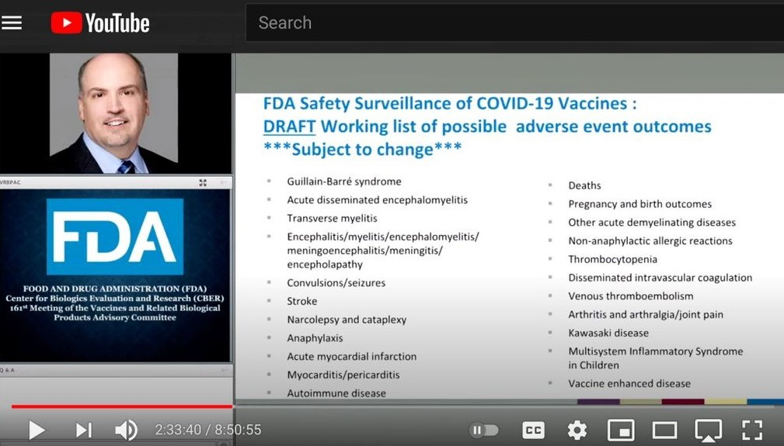

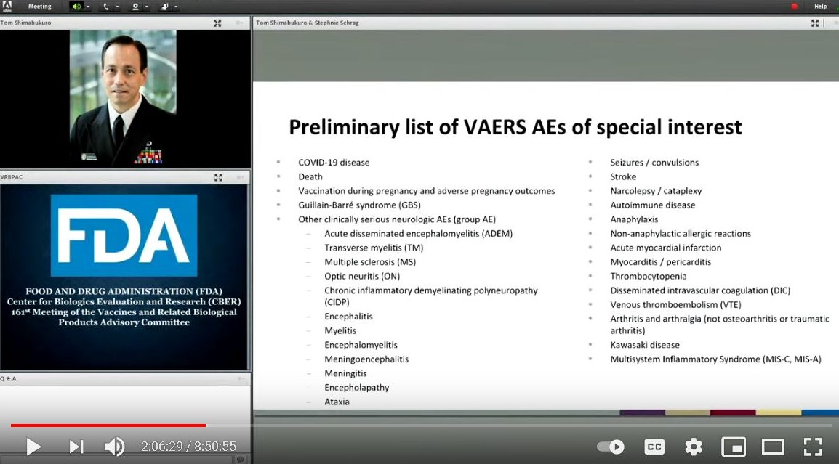

Link to evidence and conference on FDA web site https://www.fda.gov/media/143557/download
and www.data-analytica.org/FDA2.pdf
According to Science and top scientists, the main causes of covid19 vaccine injuries, disabilities and deaths are:
(a) the spike proteins in the organs and blood vessels of the body and the complications, clotting, hemorrhages, new diseases and inflammatory damage they cause including significant damage to the nervous system and vascular system and reproductive system
(b) the Antibody-dependent enhancement (ADE) that this vaccine causes. Scientific trials of similar vaccines in the past for SARS 1 (covid19 is SARS 2) showed that Antibody Dependent Enhancement (ADE) led to high death rates among animals when exposed to wild forms of SARS. The same risks of Antibody Dependent Enhancement (ADE) and deaths / serious injuries apply to the present covid19 vaccines especially in Winter and Spring. ADE is believed by top scientists to be playing a significant role in the generation of new variants of covid19.
(c) the toxicity of the grapheme oxide in the vaccines.
(d) Vaccine-driven disease enhancement in the previously infected
Most people who got the covid19 vaccines did not give their informed consent. They were not told the risks and dangers involved and the high rate injuries and disabilities and deaths caused by the vaccine. This breached their legal and Constitutional rights and Human Rights.
The current trajectory of all of this fraud is towards the selling of more vaccines and more booster shots for years into the future and more and more vaccine caused injuries, illnesses and deaths for 2021 which are being classified as covid19 or it’s variants and this combined with the usual colds and flus which afflict people every year which will also be classified as ‘covid19’ again will lead to more lockdowns in Autumn 2021 and continuing into 2022 and 2023. This will increase the desperation for more covid vaccines and booster shots. All of this will cause more unnecessary and unjustified destruction to the Irish economy and more loss of legal rights, Constitutional rights and Human Rights along with the enforcement of a system of apartheid.
Forcing people to get experimental and unsafe covid19 vaccines through mandating vaccine passports and using discrimination and apartheid is unethical, immoral, illegal, unconstitutional and criminal. These are frauds and serious crimes being committed against the Irish people and they have imposed and are imposing massive losses and infringement of their legal and Constitutional rights. This must be brought to the courts.

More News Reports about Vaccine Deaths and Serious Disabilities

Scientist Sounds Alarm: COVID Vaccines Producing Symptoms of Parkinson’s, Other Neurodegenerative Disorders
Immunologist and former NIH scientist J. Bart Classen analyzed data on COVID vaccine adverse events reported to the UK’s Yellow Card system and found thousands of reports of multiple symptoms that are “clear signals” of neurodegenerative disorders.
Source: https://childrenshealthdefense.org/defender/scientist-warning-covid-vaccines-parkinson-neurodegenerative-disorders

Scientist Sounds Alarm: COVID Vaccines Producing Symptoms of Parkinson’s, Other Neurodegenerative Disorders
The Defender July 2021. https://childrenshealthdefense.org/defender/scientist-warning-covid-vaccines-parkinson-neurodegenerative-disorders/

Infection Fatality Rate (IFR)

Dr. John Ioannidis a Professor of Medicine and Statistics at Stanford University and one of the top Epidemiologists in the world has published the following scientific research which shows that covid19 has the same mortality as flu seasons in the past.
‘ Findings: I included 61 studies (74 estimates) and eight preliminary national estimates. Seroprevalence estimates ranged from 0.02% to 53.40%. Infection fatality rates ranged from 0.00% to 1.63%, corrected values from 0.00% to 1.54%. Across 51 locations, the median COVID-19 infection fatality rate was 0.27% (corrected 0.23%): the rate was 0.09% in locations with COVID-19 population mortality rates less than the global average (< 118 deaths/million), 0.20% in locations with 118-500 COVID-19 deaths/million people and 0.57% in locations with > 500 COVID-19 deaths/million people. In people younger than 70 years, infection fatality rates ranged from 0.00% to 0.31% with crude and corrected medians of 0.05% .’
Infection fatality rate of COVID-19 inferred from seroprevalence data. 2021 https://pubmed.ncbi.nlm.nih.gov/33716331/

This corroborates our evidence and shows that it is equivalent to a flu season which we have had for hundreds of years.

The Ineffectiveness of Masks in covid19 and the health dangers of Masks
‘47 studies confirm ineffectiveness of masks for COVID and 32 more confirm their negative health effects’ at https://www.lifesitenews.com/news/47-studies-confirm-inefectiveness-of-masks-for-covid-and-32-more-confirm-their-negative-health-effects
Lifesite News July 23 2021

More information on the so called “Delta Variant” previously called the “Indian Variant” being misused to terrorise Ireland and other countries
The following video presentation by Dr. Ivor Cummins on June 30th 2021 provides the scientific facts and evidence and statistics about the Delta variant of covid19 in 2021. Dr. Ivor Cummins can be subpoenaed into courts and tribunals to confirm and verify these scientific findings. Click on video below:
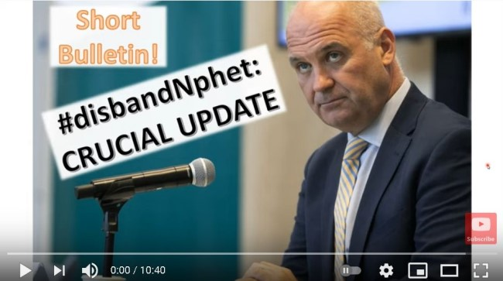

also available on https://odysee.com/@IvorCummins:f/a-short-crucial-update-on-the-delta:1

and https://www.youtube.com/watch?v=6TR0Nrds16Y and https://thefatemperor.com/videos/
and https://www.bitchute.com/video/ayCAKp1Dv9S6/

Conflicts of Interest of NPHET members and Tony Holohan CMO, the Minister for Health and Government Ministers and RTE need to be thoroughly investigated nationally and internationally
In 2020 Pfizer gave 250,000 euros to the HSE in Ireland. This was exposed by Mr. Ben Gilroy in August 2021 and presented online on https://mch.honeycommb.com/posts/12914398 . Further details are available on https://www.transferofvalue.ie . In 2017 Big Pharmaceutical companies gave 3.7 million euros to hospitals and the HSE in Ireland. These actions in 2020 and 2017 may be illegal and be a breach of certain laws. Companies make large payments out in expectation of certain favours or performance of certain activities. There is reasonable cause to believe that these large payments and other undisclosed or hidden payments, grants and financial inducements up to 2021 influenced the policies of the HSE and NPHET and the CMO and the Irish government in 2020 and 2021 in relation to covid19. Billions of euros in profits for Big Pharma were at stake.
The following research papers outlines this problem
Covid-19: politicisation, “corruption,” and suppression of science British Medical Journal
Sage Conflicts of Interest
Conflicts of Interest have been identified in sage which is advising the UK government https://worlddoctorsalliance.com/blog/sage-conflicts-of-interest/ and
https://www.zoeharcombe.com/2020/11/sage-conflicts-of-interest/
It is well known that many government advisors including scientists and doctors have conflicts of interest. They have shares and other financial interests (including grants) in vaccine companies and other Pharma companies which profit from the covid19 pandemic. It is in their interest to cause mass fear and paranoia.
The conflicts of interest of NPHET members and Tony Holohan the CMO and his deputy Ronan Glynn and the HSE and Minister for Health and RTE need to be fully investigated. All of their ties and their family ties to Big Pharma, vaccine makers, PPE businesses, Bill and Melinda Gates Foundation, GAVI, and investments in their businesses, and grants to their Universities and colleges and businesses and other forms of payment and inducements need to be fully investigated. The Investigators and Whistleblowers will be subpoenaed into the Irish courts to testify.
Spanish Court has declared the Lockdowns were unConstitutional and illegal
In July 2021 the highest court in Spain ruled that the Lockdowns were unConstitutional and illegal. Persons who were fined can apply for refund from the government and criminal convictions and jail sentences can be overturned. This is a great victory for freedom and democracy in Spain. We need a similar result in Ireland and in other European countries.
Press and media reports about this - https://www.bbc.com/news/world-europe-57838615
https://www.google.com/search?q=spanish+court++lockdown+unconstitutional
https://yandex.com/search/?text=spanish%20court%20%20lockdown%20unconstitutional&lr=10426
PCR Tests for covid19
- The CDC and FDA will be withdrawing their support for the PCR test for covid19 from December 31st 2021. One of the reasons cited is that the current PCR test cannot differentiate between influenza and covid19. This led to influenza and common colds being mislabelled as “covid19” or “new variants” in 2020 and 2021. And this led to a Pandemic of False Positives or ‘Pandemic of Fraud’ in 2020 and Spring 2021. This verifies the findings in our Report or Book of Evidence given to the Irish Police in May 2021.
Audience: Individuals Performing COVID-19
Level: Laboratory Alert
After December 31, 2021, CDC will withdraw the request to the U.S. Food and Drug Administration (FDA) for Emergency Use Authorization (EUA) of the CDC 2019-Novel Coronavirus (2019-nCoV) Real-Time RT-PCR Diagnostic Panel, the assay first introduced in February 2020 for detection of SARS-CoV-2 only. CDC is providing this advance notice for clinical laboratories to have adequate time to select and implement one of the many FDA-authorized alternatives.
Visit the FDA website for a list of authorized COVID-19 diagnostic methods. For a summary of the performance of FDA-authorized molecular methods with an FDA reference panel, visit this page.
In preparation for this change, CDC recommends clinical laboratories and testing sites that have
been using the CDC 2019-nCoV RT-PCR assay select and begin their transition to another FDA-authorized COVID-19 test. CDC encourages laboratories to consider adoption of a multiplexed method that can facilitate detection and differentiation of SARS-CoV-2 and influenza viruses. Such assays can facilitate continued testing for both influenza and SARS-CoV-2 and can save both time and resources as we head into influenza season. Laboratories and testing sites should validate and verify their selected assay within their facility before beginning clinical testing.
Source: https://www.cdc.gov/csels/dls/locs/2021/07-21-2021-lab-alert-Changes_CDC_RT-PCR_SARS-CoV-2_Testing_1.html

- The Wadworth Center, a New York State laboratory, analyzed the results of its July tests at the request of the New York Times (NYT): 794 positive tests with a Ct of 40: “With a Ct threshold of 35, approximately half of these PCR tests would no longer be considered positive,” said the NYT. “And about 70% would no longer be considered positive with a Ct of 30! “ See news story at
https://www.zerohedge.com/medical/covid-19-rt-pcr-test-how-mislead-all-humanity-accepting-societal-lock-downs
- The following scientific study provides more evidence about False Positives - ‘Correlation Between 3790 Quantitative Polymerase Chain Reaction–Positives Samples and Positive Cell Cultures, Including 1941 Severe Acute Respiratory Syndrome Coronavirus 2 Isolates’ at https://academic.oup.com/cid/article/72/11/e921/5912603 found that at 25 cycles of amplification, 70% of PCR test "positives" are not "cases" since the virus cannot be cultured, it's dead. And by 35: 97% of the positives are non-clinical.
- An uncensored video lecture by Dr. Sam Bailey a medical doctor and scientific researcher details the many defects and errors in the PCR test for covid19.
https://odysee.com/@drsambailey:c/Once-Upon-A-Time-in-Wuhan-Odysee-Exclusive-Comp:2
- A recent News report in USA stated the following:
‘the “casedemic" is the elevated number of cases we see nationwide because of a flaw in the PCR test. The number of times the sample is amplified, also called the cycle threshold (Ct), is too high.
It identifies people who do not have a viral load capable of making them ill or transmitting the disease to someone else as positive for COVID-19.
The New York Times reported this flaw on August 29 and said that in the samples they reviewed from three states where labs use a Ct of 37-40, up to 90% of tests are essentially false positives. The experts in that article said a Ct of around 30 would be more appropriate for indicating that someone could be contagious - those for whom contact tracing would make sense.
Just a few days earlier, the CDC had updated its guidelines to discourage testing for asymptomatic individuals. It can only be assumed that the rationale for this was that some honest bureaucrat figured out the testing was needlessly sensitive. He or she has probably been demoted.
This change was preceded by a July update that discouraged retesting for recovered patients. The rationale for the update was that viral debris could be detected using the PCR test for 90 days after recovery. The same would be true for some period of time if an individual had an effective immune response and never got sick. Existing immunity from exposure to other coronaviruses has been well documented. These are many of your “asymptomatic” cases.
However, due to political pressure and corporate media tantrums, the new guidance on testing was scrapped, and testing for asymptomatic individuals is now recommended again. Doctors do not receive the Ct information from the labs to make a diagnostic judgment. Neither the CDC nor the FDA has put out guidelines for an accurate Ct to diagnose a contagious illness accurately.
Hence, our current “casedemic.” Positive tests as they are counted today do not indicate a “case” of anything. They indicate that viral RNA was found in a nasal swab. It may be enough to make you sick, but according to the New York Times and their experts, probably won’t. And certainly not sufficient replication of the virus to make anyone else sick. But you will be sent home for ten days anyway, even if you never have a sniffle. And this is the number the media breathlessly reports.’
- In response to these concerns and the actual "science", Florida's Department of Health decided in 2020 that, a state will require that all labs in the state report the critical “cycle threshold” level of every COVID-19 test they perform. This should be done in every country so as to avoid PCR test frauds and fraudulent covid19 cases.
- In early January 2021, the FDA issue a public statement about the dangers of False Positives for covid19 titled ‘Risk of False Results with the Curative SARS-Cov-2 Test for COVID-19: FDA Safety Communication’ available at
https://www.fda.gov/medical-devices/safety-communications/risk-false-results-curative-sars-cov-2-test-covid-19-fda-safety-communication?
and the WHO stated similar concerns at https://www.who.int/news/item/14-12-2020-who-information-notice-for-ivd-users
and there are news reports about this at https://www.zerohedge.com/medical/who-finally-admits-pcr-tests-create-false-positives
- Within a few hours of Joe Biden being inaugurated as president and signing an executive order mandating masks on all federal property, the WHO sent out a notice to lab professionals using the PCR test. It said:
‘WHO guidance Diagnostic testing for SARS-CoV-2 states that careful interpretation of weak positive results is needed (1).
The cycle threshold (Ct) needed to detect virus is inversely proportional to the patient’s viral load.
Where test results do not correspond with the clinical presentation, a new specimen should be taken and retested using the same or different NAT technology.’
Literally a few hours after Biden takes the oath, the WHO admits that PCR testing at high amplification rates alters the predictive value of the tests and results in a huge number of false positives.
- Leo: Covid cases in hospital counted even when patients admitted for other reasons
See attached News report in next page
Source: https://gript.ie/leo-covid-cases-in-hospital-counted-even-when-patients-admitted-for-other-reasons/
and a similar news report ‘Exclusive: Over half of Covid hospitalisations tested positive after admission : Leaked data suggest vast numbers classed as being hospitalised by the virus when they were admitted with other ailments’
from the Telegraph in Britain is also attached.
- The new evidence and findings above verify and confirm the evidence in our Report or Book of Evidence given to the Irish police in May 2021.

Important New Scientific Book about covid19 written by experts such as medical doctors and scientists
- The recently published book ‘Virus Mania: Corona/COVID-19, Measles, Swine Flu, Cervical Cancer, Avian Flu, SARS, BSE, Hepatitis C, AIDS, Polio, Spanish Flu. How the Medical ... Making Billion-Dollar Profits At Our Expense’ 3rd Edition, April 2021 by Torsten Engelbrecht, Claus Köhnlein , Samantha Bailey, Stefano Scoglio corroborates the Evidence in our Report or Book of Evidence given to the Irish police and legal authorities in May and July 2021. It is available at
https://www.amazon.com/Virus-Mania-COVID-19-Hepatitis-Billion-Dollar/dp/3752629789
Conference of Top Scientists and Medical Doctors in London, England in July 2021 which corroborates our evidence presented to Irish police and legal authorities
- Some top scientists and medical doctors and professors from around the world held an important conference about covid19 and lockdowns in London in July 2021. The evidence they provided corroborates all of the evidence we have gathered and presented to the police and legal authorities in Ireland. They provided evidence of the failure of lockdowns , the legal and economic repercussions of this failure, the conflicts of interest and corruption behind lockdowns , the availability of effective medicines for covid19 in 2020 and the deliberate blocking of these medicines and how to live with covid19 and coronaviruses , colds and flus as we have done so for hundreds of years.
This is evidence which needs to be presented in courts worldwide. A link to videos of this scientific conference is provided below:
https://www.questioneverything.io/
https://www.youtube.com/watch?v=xzeFfQQHGWs
More Scientific Evidence that the covid19 virus was engineered in labs. Sinister Agenda needs to be fully investigated in all countries
New scientific findings are confirming a lab leak was involved. This contradicts what the WHO, the NIH and Fauci and Jeremy Farar many other ‘authorities’ claimed in 2020 and Spring 2021 as they wrongly alleged that the virus emerged in the wild from bats or intermediary animals and not from labs. Lies and deception have been used by these “authorities” to mislead the general public and governments. This needs to be thoroughly investigated by police and military and intelligence agencies in all countries. Covert and undercover investigations required to expose lies, deception, misdirections, conflicts of interest, advisors lying to government, false statistics, hidden evidence, and cover ups. These “authorities” need to be brought before Parliamentary Tribunals and criminal courts and Nuremberg type tribunals These deceptions and lies have adversely affected Ireland including NPHET, the CMO the government and government policies and laws around covid19 in 2020 and 2021. It also affects what has been reported in the press and media in Ireland.

The Science Suggests a Wuhan Lab Leak
The Covid-19 pathogen has a genetic footprint that has never been observed in a natural coronavirus
Wall Street Journal June 6th 2021
https://www.wsj.com/articles/the-science-suggests-a-wuhan-lab-leak-11622995184

US Senator Rand Paul is bringing criminal charges against Dr. Anthony Fauci, head of the NIH over lying to Congress and the illegal funding of gain of function studies for coronaviruses including covid19.
https://thepostmillennial.com/breaking-rand-paul-will-send-criminal-referral-letter-about-fauci-to-the-doj and
https://conservativebrief.com/rand-paul-45848/

News story - https://unherd.com/2021/07/how-scientists-stifled-the-lab-leak-theory/

More scientific evidence provided on the Highwire news channel in the USA - https://www.bitchute.com/video/wtyX1JUfcqof/
Illegal and Unconstitutional Censorship of social media and of free speech and of Science and the Conflicts of Interest involved in this. And the promotion of lies, deception and cover ups in the press and media in relation to covid19 in 2020 and 2021. Complicity in the committing of crimes.
- Thousands of people have been censored in Ireland by Facebook, Twitter Google and Youtube in order to block and prevent the evidence, facts and truth about covid19 and vaccines emerging and being discussed online. This has acted to undermine and block the legal requirement of informed consent for those trying to make a choice about vaccines. There have been serious breaches of Constitutional rights and Human Rights.
- The Highwire news show in the USA has produced evidence of the reasons for the illegal censorship of social media and the Internet and the Conflicts of Interest involved in 2020 and 2021. Also some evidence of deliberate deception and cover ups. This is to be used in Congressional investigations in the USA. This has adversely affected Ireland including NPHET, the CMO the government and whats has been reported in the press and media in Ireland.
https://www.bitchute.com/video/wtyX1JUfcqof/
- The Trusted News Initiative set up in 2020 has been used to censor science and medicine and all scientists and doctors who have tried to expose the scientific facts and evidence about covid19 and who disagree with the narrative of the government. It covers news channels online and offline/.

Food Security and Irish National Security
The Covid19 Frauds have led to more frauds and the “Pingdemic” in Britain which is causing break downs of supply chains and leading to food shortages in Britain and Ireland. Over 70% of Irish food goes through British ports and this will affect Irish food supplies. These covid frauds and related food shortages are a threat to the Irish people and nation. See news reports below.

https://yandex.com/search/?text=pingdemic+food+shortages

https://www.google.com/search?q=pingdemic+food+shortages

The role of the World Economic Forum and it’s “Strategic Intelligence” agenda in the Covid19 Policies, Laws and Regulations in many countries including Ireland
The World Economic Forum (WEF) meetings are attended by political leaders of countries, presidents of countries, EU Commission and Parliament politicians and leaders, royalty, the heads of big corporations and commercial banks and central banks, press and media leaders, leaders of UN, IMF World Bank and other big international organizations every year. It has international power and influence. The World Economic Forum’s reaction to covid19 has been to put forward it’s “Strategic Intelligence” agenda on its web site and this correlates to the Great Re-set proposed by them. This includes:
- centralized government control via digital ID’s and vaccine passports
- increased surveillance and monitoring of populations
- social credit systems linked to Digital ID’s / vaccine passports similar to Communist China to control the people
- linking Digital ID’s / vaccine passports to forms of compliance and conformity even where this breaches Constitutional rights, legal rights and Human Rights
- denying goods and services and foreign travel to persons who have no Digital ID’s / vaccine passports. The use of apartheid in societies to enforce compliance.
- the unlawful use of masses of people for live experiments with drugs or pathogens or vaccines for profit while corporations are protected from legal actions. Treating human beings as animals or chattel.
- the manipulation of climate change agenda to facilitate more totalitarian government and the enforcement of the plan outlined here
- the use of fear to create totalitarian government and the end of democracy and freedom and national sovereignty. A hybrid of Communism and Fascism. We have seen a progression towards this in 2020 and 2021.
- the end of nation states and national identity their replacement with multiculturalism and globalist government and globalism
- the use of censorship of the press and media and of the Internet to enforce this agenda
- the loss of Constitutional rights and Human Rights for ordinary people in all countries. The use of coercion and violence in many different forms to push this agenda through
- governments controlled and over-ruled by technocrats and a global elite
- the use of and manipulation of mass fear and panic to drive political and WEF agendas
- profiteering from the creation of mass fear and panic
- increased concentrations of wealth and inequalities through global corporations and globalism
- support for a global elite which is above all laws, Constitutions and rules.
This is Treason in Ireland and in most democratic countries.
This agenda is being followed by many governments including the Irish government and EU government and Commission.
Web site – https://intelligence.weforum.org and https://digital-members.weforum.org/intelligence
their video - https://www.youtube.com/embed/ww5WcMWOLFI and https://www.youtube.com/watch?v=N_599-9xdpY or www.data-analytica.org/wef.mp4
Criminal Intent
Criminal Intent always involves personal enrichment and/or group enrichment through illegal or unlawful or unjust means which cause losses and/or harms to another person or persons. In law, fraud is often the first step in the committing of crime and this provides the means for further criminal activities to ensure personal or group enrichment. A fraud which creates mass fear and panic while pretending to offer a solution is the perfect instrument of fraud and crime. It hides the fraud behind false perceptions of “good intentions” , the “common good” and “the public interest”. Fraud and lies and deception which cause a misuse of the state’s resources and the state’s power to enforce a certain outcome involving the acquisition of massive profits and/or pay offs for certain parties provides Intent, Motive and Opportunity - the ingredients of crime. And there is the reassurance that the state will protect its own state criminals and allow crimes and frauds to go uninvestigated and unprosecuted and unpunished.
The criminal intent involves:
- The use of a fraudulent PCR test with high cycle counts (35 to 45) to create false positives for covid19 as high as 97% and false statistics and create massive public fear and panic. The scientists and doctors and government advisors knew about the high Rate of False Positives for covid19 by October 2020 but they persisted in supporting and enforcing this PCR test with it’s high rate of False Positives for
covid19. It was a Pandemic of False Positives. And the government and its advisors including NPHET cynically used the press and media to inflame this panic and fear of covid19. This was used to create mass fear, panic and paranoia in the general public so as to get public support for lockdowns and to introduce lockdowns and to profiteer from this as detailed in our reports. Hitler used similar fear tactics to pass the Enabling act in 1933 under the guise of “protecting the public” and this was used to create a “New Normal” or “Re-set” involving dictatorship and fascism. These same tendencies still exist today.
Why would people wish to create fraudulent PCR tests with high rates of False Positives and create mass panic and fear and oppressive lookdowns which destroy the economy and society ? The answer is obvious – massive profits and personal enrichment and/or group enrichment. Crime is always done for financial gains and other advantages. In law, fraud is often the first step in the committing of the crime and this provides the means for further criminal activities to ensure personal or group enrichment. In law, fraud vitiates everything. This means all policies, laws and measures which proceed from fraud can be struck down in court and declared null and void.
- Several studies show that 90% - 95% of the people who died from covid19 in 2020 had 2 – 3 serious illnesses which could have killed them and most were elderly and the average of death from covid19 in Ireland was 82 and the median age was 84. This was the same in most other countries. And our evidence shows that healthcare systems mislabeled many deaths as covid19 and there were financial incentives to do so. This enhanced and worsened the covid19 fraud.
- Lockdowns which are the deliberate shutting down of economies and societies lasting over 12 months were calculated to create mass desperation and fear and this was used to force the sale of PPE and experimental, untested and dangerous covid19 vaccines for massive profits. The intent is to continue these covid19 vaccines into the future by promoting more booster shots and more public fear of alleged “variants” of covid19 accompanied by dependency on vaccine passports and vaccine shots all of which will be followed by fears of new viruses and new strains of viruses which may also emerge from labs in the future thus providing massive profits for vaccine makers over an extended period of time. The motivation and intent is massive profits on a global scale.
If the intent and motivation was to save lives from covid19 in 2020 and 2021 then why did the government and medical authorities block and ban several effective cheap and safe medicines for covid19 in 2020 and 2021 ? The government and NPHET knew these medicines were safe and effective in 2020 and 2021. There are many published scientific studies and papers and also clinical studies by doctors verifying that these medicines work. The government and NPHET had been supplied with the Great Barrington Declaration authored by top scientists and doctors in October 2020 which called for Focussed Protection but they ignored this and refused to implement it. And why did the government and NPHET deny and lie about pre-existing immunity to coronaviruses including covid19 among most of the population when this was already known by November 2020.
The legal term “Qui Bono” applies here. Who benefits financially from this ? Why go to such extreme measures as lockdowns of a whole country for over 12 months when effective medicines are already in place since March 2020 and the Infection Fatality rate was known to be 0.23% then and later to be 0.15% which are comparable to a flu season ? in Spring 2021 the Infection Fatality rate was known to be 0.15% but the governments continued with lookdowns into Summer 2021. These were very extreme measures by politicians for something which was equivalent to a flu season which we have had for hundreds of years. We never locked down countries for colds and flu’s in the past.
- The FDA and US government knew about the high risk of deaths and serious injuries and disabilities from these covid19 vaccines prior to giving them emergency authorization in December 2020. The European authorities (EMA) and Irish authorities knew about the high risk of deaths and serious injuries and disabilities from these covid19 vaccines prior to giving them emergency authorization in January 2021. And these governments and authorities in North America and Europe including Ireland have known about deaths and serious injuries and disabilities from these covid19 vaccines after January 2021. Yet they still inflict this harm on peoples and nations and certain vested interests with political connections to the government and NPHET and the CMO are profiteering from this. The criminal intent is clear here.
- Highly effective and safe medicines were blocked and banned by the government and NPHET and CMO in 2020 and 2021 but experimental vaccines which are mostly ineffective and quite dangerous were immediately legalized and promoted. But the latter create massive profits for certain vested interests with political connections to the government and NPHET and the CMO who are profiteering from this. The criminal intent is clear here.
- Over 1 million Irish people received the covid19 vaccines in 2021 but they did not give their informed consent as they were not fully informed about the risk of deaths and serious injuries and disabilities from these covid19 vaccines. This is against the Irish Constitution and EU and UN Human Rights laws and the Nuremberg Code. All of this was done for profit and for financial gains by those in political power and among government advisors. The criminal intent is clear here.
- Profiteering from Coronaviruses: Peter Daszak of the Eco Health Alliance has been a key player in the covid19 scandal. His organization received funding from the NIH in the USA and used it to fund gain of function research for coronaviruses and other viruses in the Wuhan lab in China. He played a major role in getting the general public and scientific community to believe that the covid19 virus was not manufactured in a lab. He has links to WHO, the NIH, the Wuhan lab and GAVI and worked closely with them in 2020 and 2021. This statement that was made by Peter Daszak in 2015, and reported in the National Academies of Press publication February 12th, 2016, provides an insight into him: “We need to increase public understanding of the need for medical countermeasures such as a pan-coronavirus vaccine. A key driver is the media, and the economics will follow the hype. We need to use that hype to our advantage, to get to the real issues. Investors will respond if they see profit at the end of the process.”
Profiteering from lab coronaviruses and mass panic and fear and their rushed and partially tested vaccines is the business model here. This is being investigated by the US government and many other governments. News reports about this on https://peterdaszak.com/ and https://www.ukcolumn.org/community/forums/topic/peter-daszak-the-eco-fascist-who-created-the-pandemic/
- Why were lies told about flus and colds and bacterial pneumonia in 2020 – lies stating that they mysteriously disappeared and were all replaced by covid19 ? and defective PCR tests used to mislabel colds and flu’s as coivid19 ?
- Why was important scientific and medical evidence ignored and even censored by Government advisors and Ministers in 2020 and 2021 ? and why were great efforts made by governments and their allies in the press and media and medical bodies to silence and threaten all scientists and medical doctors who disagreed with the government narrative ? why was science and medicine censored in 2020 and 2021 ?
- The mortality figures and excess mortality for 2020 show no significant increase in mortality for 2020 compared to the previous 7 years so why did the government and press and media spread false rumours that many thousands were dying of covid19 ? and that the government had to enforce lookdowns to protect the Irish nation ?
- Government advisors and government ministers with Conflicts of Interest created the false narrative above and profiteered from this. This official government narrative was ruthlessly enforced on medical bodies and doctors and scientists. Censorship was enforced and all dissenters were blackmailed or fired from jobs. Massive financial gains for some people in political power and corporate power shields them from the extreme measures that they enforce on other people.
- Press and Media stations were forced to rely on government handouts to survive and forced to follow the government narrative. Censorship was enforced contrary to Irish laws and the Constitution.
- Mr. Bill Gates openly and publicly admitted in 2019 that massive profits would be made from vaccines in 2020 and subsequent years. He is the biggest funder of the WHO and of GAVI and of Universities and Professors and government advisors who were involved in vaccine research and he is a major investor in vaccine companies. There are people and organisations here with many conflicts of interest who have profiteered from the covid19 vaccines and harsh government measures.
- Continuing to administer and profiteer from dangerous covid19 vaccines may constitute the crime of poisoning and grevious bodily harm and manslaughter / murder. The profiteering from these vaccines has been clearly established and provides the intent and motive and opportunity.
- The mislabeling of covid19 vaccine deaths and injuries and disabilities as covid19 or variants of covid19 so as to keep this ‘pandemic’ going indefinitely for more years and enforce more lookdowns.
- The misuse of state resources and power can and always has been used by some unscrupulous people for personal enrichment and/or group enrichment while causing massive losses to others. This is the key factor here.
- Nursing home deaths could have been avoided by government and state actions in 2020 but they refused to do so and this resulted in involuntary manslaughter in nursing homes. The elderly were cruelly and callously ignored at the time. This fed into the creation of more panic and fear being promoted by the government and their controlled press and media and the overall objective of massive financial gains to be made from such fear, panic and desperation.
- Cover ups of vaccine deaths and the scientific and medical facts and evidence about covid19 from March 2020 up to the present day were done for the financial gains mentioned above.
- Frauds, deception and lies from foreign countries and bodies were accepted by Irish government and NPHET and state bodies here and became part of government policies, regulations and laws in Ireland.
- The continuing attempt to destroy Irish Democracy and Freedom and Human Rights and replace them with lookdowns, experimental and dangerous but profitable vaccines and booster shots, censorship of the press and media, censorship of scientists and medical doctors, vaccine passports accompanied by discrimination and medical apartheid and linking this to access to government services, the tracking and tracing of people, increased police powers and surveillance and a totalitarian government is Treason against the Irish Constitution and the Irish people and nation and a serious criminal offence.
- China and its communism and totalitarianism has become the model for dealing with covid19 and the post covid19 world in many countries worldwide including in Ireland, the EU, Australia, Many US states, Canada, etc.. The so called “Great Re-set” and “New Normal” being proposed by Klaus Schwab and strongly supported by several governments including the Irish includes plans for totalitarian government and vaccine passports and apartheid and linking this to social credit currency and access to government services, the tracking and tracing of people and massive profiteering from this, and bolstering this with increased censorship and police powers and more surveillance of the population while depriving them of their Constitutional rights and Human Rights. This is Treason in all democratic countries. Profiteering from treason is a crime.
- Many frauds and crimes identified in our Book of Evidence and supporting evidence point to unjust enrichment through PPE and covid19 vaccines and continuous booster shots into the future and dependency on vaccine passports and constant vaccine shots and the accompanying massive grants to universities and other organisations, “investments”, bribes and other forms of financial inducement as the Motivating Factor and the Intent for the committing of these crimes and for collaborating and colluding with them. And the creation of more totalitarian governments to facilitate such frauds and crimes into the future.
Nuremberg Tribunal Trials of 1946 and Similarities to Today
Medical experiments were carried out by doctors and scientists and “Experts” before and during world war 2. It was research for profit. Twenty medical doctors also called 'Medical Experts' and 'Government Advisors' were put on trial in the Nuremberg trials of nazis and fascists in 1946 and 1947. Many were executed. There are close correlations to what is happening today.
Link : https://www.google.com/search?q=nuremberg+tribunal+doctors
See picture of Nuremberg trial below.
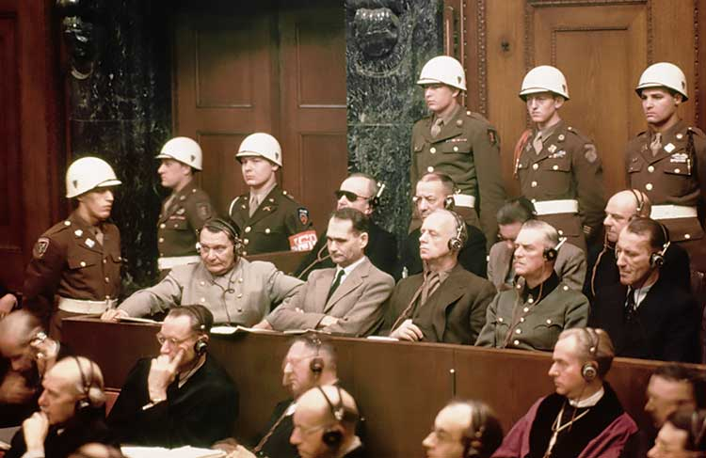
Subpoena of all scientists and medical doctors and Whistleblowers for the Irish Criminal Courts and Civil courts
We subpoena all scientists and medical doctors and Whistleblowers mentioned in our Report and Evidence documents to the Gardai (Irish police) to the criminal courts and civil courts in Ireland.

Amendment to Statement to Garda (Irish Police) on May 7th 2021 and to the List of Charges

We add the following to the section of our statement to the Gardai (Irish Police) on May 7th 2021

‘Following an important and highly relevant court case in Alberta, Canada - Deena Hinshaw vs Patrick king in July 2021, the court ruled that the Canadian government had no evidence that sars-cov2 virus or covid19 virus existed as it had NOT been isolated and purified and its full genome identified. The virus has not been proven to exist. This was accepted by the prosecutor and the defendant and the judge in court. The court accepted and ruled that they have no evidence of this virus. All covid19 restrictions have been removed in Alberta in Canada after this court case. This has serious implications for courts in Ireland and in many other countries. And serious implications for laws and guidelines based on this virus meaning they are illegal and unlawful in Ireland and other countries.
News Reports about this on Bitchute
https://www.bitchute.com/video/pGITK5Z7l2rj/
and https://www.bitchute.com/search/?query=patrick%20king%20&kind=video&sort=new

- We call on NPHET, Dr. Tony Holohan, the Minister for Health, the Taoiseach (Prime Minister) and RTE to produce evidence of the sars-cov2 virus also known as the covid19 virus including its isolation and purification and its full genome and transmission of this from person to person. If the evidence is not there and cannot be presented then this corroborates the false statistics charge against them in our original statement to gardai (Irish Police). If this evidence is not there and cannot be produced then we ask them to publicly state this to the Irish public and to immediately repeal and remove all laws and guidelines pertaining to covid19 including lockdowns, mandatory masks, promotion of covid19 vaccines and mandatory vaccine passports for accessing goods and services.
- We request Court Orders of Discovery in relation to the above matter and other matters detailed in the original statement to the Gardai on May7th 2021
- The number of covid19 variants caused by covid19 vaccines and ADE and other biological complications caused by these vaccines in Ireland and internationally.
- The number of covid19 vaccine injuries and disabilities and deaths mislabeled as covid19 or covid19 variants in Ireland.
- The number of people hospitalized after getting the covid19 vaccine with nown injuries and disabilities caused by that vaccine.
- Autopsy reports of dead vaccinated people to determine the level of spike proteins in the organs of the body and the damage caused. Autopsy and scientific studies abroad of dead vaccinated people confirm spike proteins in most organs of the body and significant damage caused.
- Can Nphet and CMO and government explain the big increase in deaths in nursing homes in 2021 after the introduction of covid19 vaccines when covidq19 cases and deaths were decreasing ? See attached statistics. How many older people in nursing homes were killed by the covid19 vaccines in 2021 ?
- The reasons for the large increase in deaths in Summer 2021 when covid19 cases and deaths were decreasing. Deaths which were above excess mortality for that time of year. We attach statistics. Were these deaths from covid19 vaccine injuries and disabilities ?
- Nphet and CMO and government plans and statistics to wrongly blame the covid19 variants on the unvaccinated. And their plans for more lockdowns in 2021 and 2022 and to blame the unvaccinated.
- The number of covid19 variant infections and hospitalisations among the covid19 vaccinated and the unvaccinated. In many countries official statistics show that there are more covid19 infections and hospitalisations in the vaccinated.
- For the purpose of establishing the facts and accurate statistics about covid19, the conflicts of interest of NPHET members and Tony Holohan the CMO and his deputy Ronan Glynn and the HSE and Minister for Health and RTE and Dr. Luke O’Neill need to be fully investigated and detailed. ‘

